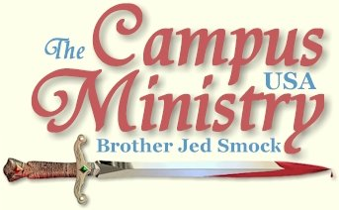
brojed@aol.com
brojed.org
573-999-0346
573-999-0346

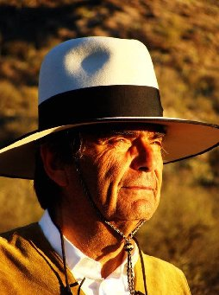
Prayer request: Bro. Jed, Martha and Evangeline have been ministering at the University of Arizona in Tucson all week. They have had large attentive crowds with lots of open hearts. Tomorrow is their last day at UA so pray that souls will be saved!

AHA!
New Mexico State University, February 7, 2011
We arrived on campus at 11:30. We just missed a class break. I decided not to wait until the next passage; I started preaching at 11:40. I did not speak at my loudest volume. I spoke slowly and deliberately most quoting Scriptures. There were a few students sitting around when I began. Martha stood beside me holding the warning sign listing sins. It was not long before a boy wearing a shirt which said, “Sin Stinks” approached me complaining about my approach. I gave him some attention, others professing Christians joined in his complaint. By the next class break I had an audience. The breaks on this campus do not have a large number of students.
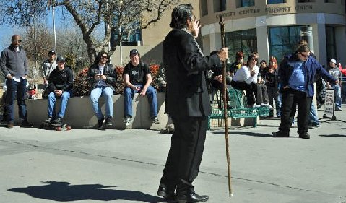
"...a boy wearing a shirt which said, “Sin Stinks” approached me complaining about my approach."
Soon a gross and vulgar lesbian confronted me with her sin. Virtually, every sentence included the F-word. She said that she had confrontations with me in years past. When I said that I did not remember her, she replied, “Oh, I suppose all lesbians look the same to you.” I respond, “No, but they all tend to sound the same. I notice that they typically have a very foul mouth.” This is not surprising considering where they put their mouths.
Another girl who claimed her Catholic pastor had affirmed her in her lesbianism. Another degenerate, who was a chain smoker and professing communist, spoke with a Mid-Eastern accent. He claimed to have been born in the US, but had lived abroad for much of his life. He admitted that he was just there to mock. He stayed for the whole afternoon.
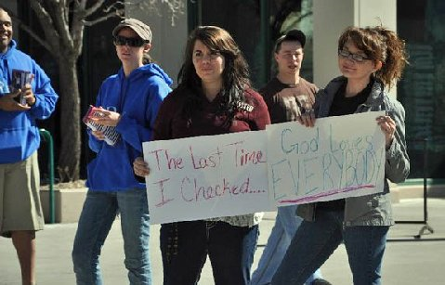

A Christian girl with a meek spirit boldly stood up for the gospel. The Communist also mocked her. Meanwhile, Christians and a reporter were questioning Martha. She spent a lot of time with the “Sin Stinks” boy, who later came up and shook hands with me and said, “You are doing a good job, be encouraged.”
Martha did her skit and afterwards had even more students talk with her. She was involved on the sidelines for most of the afternoon. There were a few times after 2:30 that it look liked the crowd would die out. I was never overly aggressive. At times for moments I would sit on my stool saying nothing. Soon things would pick up again as students started questioning me.

The Skit!
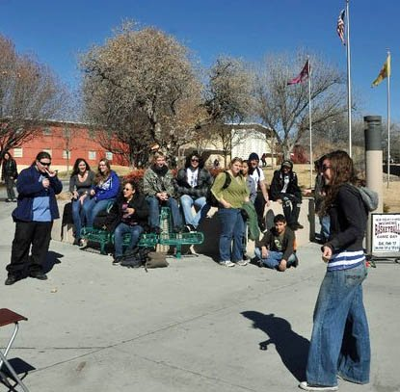
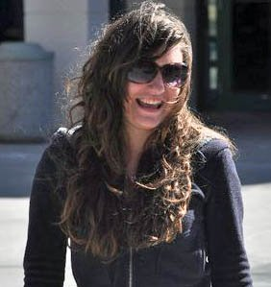
...Martha was involved on the sidelines most of the afternoon...
Late in the afternoon I did have one of those “aha” moments. A boy asked about my views concerning universal health care. He was convinced that the government control of health care was the answer. I asked him about his religious background. He said he went to catholic schools through the twelfth grade, but that he was not a catholic. I asked, “Then why did you go to Catholic schools?”
“Because I wanted a good education, private schools are better than public schools,” he responded.
“Aha, you are right! Private schools can do a better job than the public schools. And so it is with medical care; the private sector can do the job better than the public sector, just as it does in the field of education. With the government takeover of one sixth of our economy, the quality of medical care will decline.”
About 4:45, some believers began answering the questions from some evolutionists. I decided that would be a good time to bow out and let the students discuss the issue. As we drove away from the Corbett Center there was still a small group discussion going on.

THE MAN’S MONOLOGUE
New Mexico State, February 9, 2011
Feminists had a table set up in which they were promoting the play, the Vagina Monologues. In reference to Valentines’ Day they were selling chocolate vaginas to raise money for battered women. The Vagina Monologues is a depraved production which is supposed to empower women by graphic descriptions of lust, lesbianism, masturbation pedophilia and the orgasms; it is anti-men and pro-perversion. The monologues use vulgar terms in referring to the female anatomy. It is despicable theater; yet, it is annually played on thousands of college campuses world-wide.
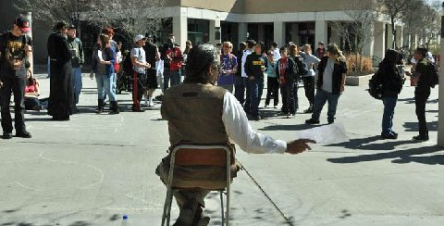


Girl unhappy with the preaching writes a message against Bro. Jed on the sidewalk.
No wonder with so many females adopting this demeaning view of women, as essentially sexual objects, that battery of women has become an increasing problem. If the women have so little self-respect that they can promote something as depraved as The Vagina Monologues, the men are not going to value them. Neither will they have a protective attitude towards women, whom the Bible calls, “the weaker vessel (1 Peter 3:7).” When women will live with men without the benefit of marriage, the men will have no regard for a whore. My comments on battered women and my references to the Biblical roles of men and women resulted in that being the dominant issue for the first two hours of my meeting. I reproved and shamed the men for allowing the feminists to emasculate them.
Of course, they tried to portray me as the one demeaning women, but it is the feminists’ movement which has degraded women. They tried to accuse me of teaching that men were superior to women. I emphasized that men and women have equal worth and are equally loved by God; however, they do have different roles. The husband is to be the head of the household. They consider this idea to be inequality. Some feminists were having a hissy.
At this point Martha was stirred in her spirit, interrupted and asked the feminists, “Why would you want to be equal? Someone has to be the head of the household and God has ordained that the husband should be the head of the wife. Someone has to make the decisions.”
They never really could answer Martha’s question. Martha did succeed, however, in calming the feminists down somewhat. Feminism is one issue that seems to stir Martha more than others. Several times this year she has spoken up without me calling upon her and it has been almost always on the issue of wives submitting to their husbands or when the females try to characterize me as a “chauvinist pig.” Martha likes to come to my defense and speak of my kindliness. I like to see the Spirit of God aroused in Martha, or anyone for that matter. Today, Martha even told the students how I have been serving her a continental breakfast in bed.
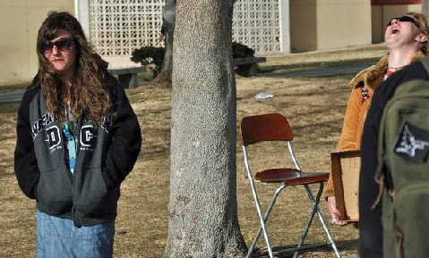
"...Martha did succeed, however, in calming the feminists down somewhat..."
Martha will make someone a good wife some day. Alas, none of my daughters seem interested in remaining virgins and simply brides of Christ for their lifetime. But one never knows.
I pointed out how many females are obsessed with piercings and tattoos which is another mark of lack of self-respect. If women will mutilate their own bodies, how do they expect men to have a protective attitude towards women, especially considering that the men will mark their own bodies? Men who will abuse themselves with alcohol, drugs and masturbation are not going to have respect for the bodies of the women they are with. Self respect is a prerequisite for regard of others.
The meeting went much like yesterday with the crowd ranging from 15 to 35 for most of the afternoon. In the middle of the afternoon a strong wind arose which was blowing away things on the feminists’ table. Other key issues of the day included Jesus being the only way and the justice of eternal damnation, and, of course, as always, my approach.
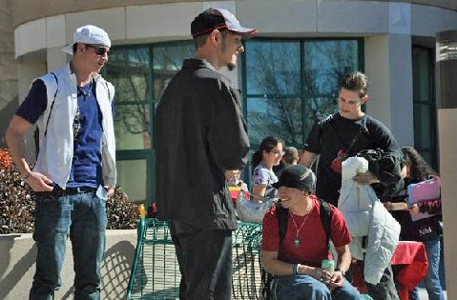
Students at New Mexico State amused by the Preaching.
At 4 PM I decided to shut down the meeting. For the last hour about a dozen students were lingering but not really engaged. However, there were two lively group discussions going on beside me which had been prompted by my preaching. Since the weather was supposed to turn cold in Las Cruces today, I decided to change our schedule and press on to Tucson which was a four hour drive.
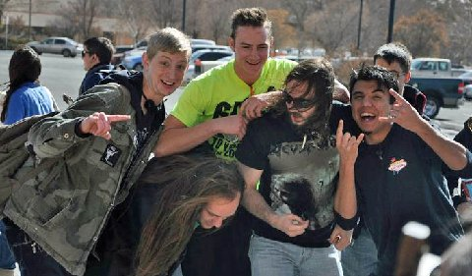
"...Other key issues of the day included Jesus being the only way and the justice of eternal damnation, and, of course, as always, my approach..." Woe unto those who laugh now!
THE HIGHLIGHT OF THE SEMESTER
University of Arizona, February 9, 2011
Brandon wrote on my facebook wall today, “Your visit to Tucson is the highlight of my spring semester!” Martha said that she heard a number of students say that my annual visits are the highlight of the semester.
Martha overheard a Jewish fraternity boy say to someone who questioned him as to why he was so loud, “I have been waiting for this all year; of course, I am going to heckle Brother Jed.” This boy pleaded with me throughout the afternoon to sing the gay song (as did others), but I refused. He also wanted me to tell stories of my college days. After teasing the students for a while, I did tell a few of these.
At the beginning of the day a girl approached me wearing a t-shirt promoting the Vagina Monologues, which prompted a similar conversation as I had at NMS yesterday. She wanted me to come to the production next week. At this time someone walked through the mall dressed up as a condom and being led by a female.
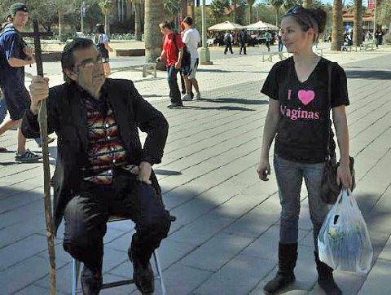
Girl Invites Bro. Jed to the Vagina Monologue Theatrical Production on Campus
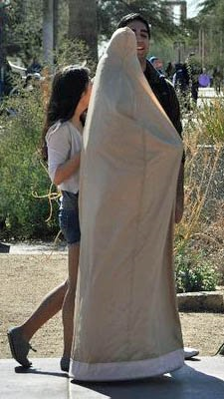
Walking Condom Led by a Female
By 1 PM the grassy hill upon which the students sit as I preach was filled and mostly remained so all afternoon.
One of the regular hecklers from last year stood beside me playing some loud decadent music for about 30 minutes. This did not go over well with the students since so many are curious as to what I have to say.
As Martha did her skit a degenerate came up to hand her some condoms. Later she also told the story of HPV Holly. Martha forgot a few of her lines; but she just smiled and tried a few more times until she finally got it right. This is typical Martha; she has never allowed messing something up to discourage her; she smiles and continues until she gets it right.
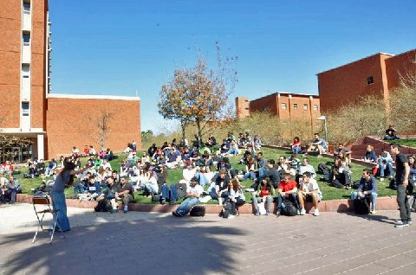
Martha continues to preach ignoring the condom distributors.
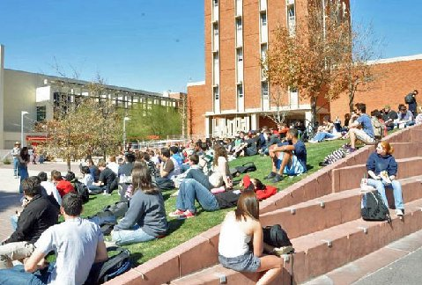
The Episcopal priest with whom I had an informal debate last year was moving through the crowd telling the students that I am not representative of Christianity. He was not wearing is clerical collar today. When I called on the local preacher Roy Spears, who regularly speaks on campus, the priest, Lucas, interrupted Roy to speak. I could not catch what he was saying because a girl had some questions for me. He and Roy then exchanged ideas before the crowd.
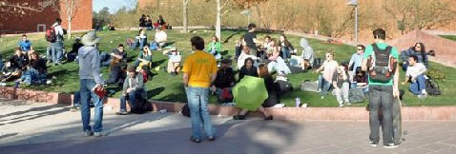
Preacher Roy Spears and the Episcopal Priest (yellow shirt) exchange ideas later in the day.
I am expecting tomorrow to be an even bigger day since the students were not expecting me today. These students are so entertained by my visits. Yet I am not getting paid anything to come on campus. The University spends big money every year bring speakers to campus and I am the one that they are waiting for. The university should be paying me to speak.
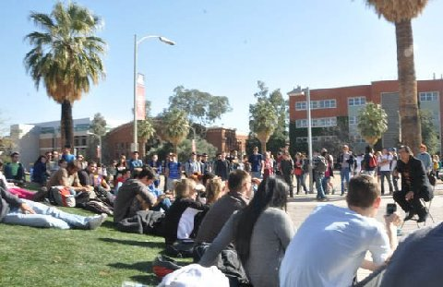
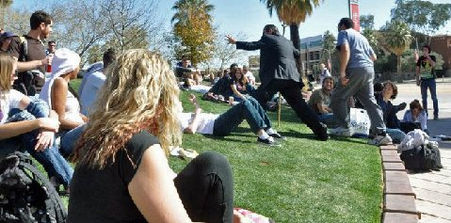
Bro. Jed makes an important point at UA
THE BROKEN RECORD
UA, February 10, 2011
When we arrived on campus there were around 25 people sitting on the hill (a number of them obviously waiting for me), so I started preaching at noon even though it was not a class break. I spoke on the nature of faith explaining that one has to have knowledge of God in order to have faith in God.
The white winged angels made up of gays, lesbians and their sympathizers arrived to protest me and attempt to be a shield preventing students on the mall from seeing me. Of course, they just draw more attention to my preaching.
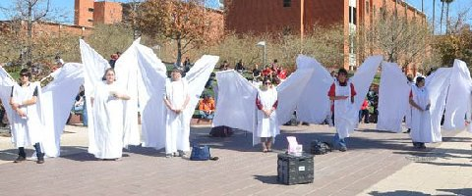
Winged Angels
Gradually more students gathered and by the end of the next break the hill was filled with people, and by now the hecklers were stirred. The Jewish fraternity boy, who had heckled yesterday afternoon continuously asking me to tell stories of my Greek days, played the same broken record today. Others joined him in requesting me to sing the gay song or do “Brother Jed’s virgin test.”
I refused to tell any of their favorite stories but just did straight teaching and occasionally illustrating with a few of my parables which are less familiar to the students. At times I did open up to questions but I insisted on only answering thoughtful questions. Sometimes I would say nothing for a few minutes as I waited for someone to ask or say something intelligent. But mostly they asked such things as, “What is wrong with homosexuality?” Finally, a boy did ask, “Why could not a loving God simply forgive sins, why did Jesus have to go to the Cross?”
I was able to expound on the atonement for 15 minutes. The questioner did seem to understand my answer. Around 2 PM the broken record got off the hill and persistently pestered me about telling this or that story. I told him, not as long as he wanted me to. I was growing weary of the frivolous behavior of a number of students so I announced, “I am taking a break” even though Roy had not yet arrived to relieve me. Normally, I do not take breaks since sometimes it is difficult to regain a crowd once it is lost. However, I knew students on this campus really wanted to hear me.
There is a group of students who have formed the Hill Society. They regularly gather on the hill to discuss philosophy and the issues of the day. They sit together on the hill and have behaved civilly the last two days. Roy had introduced me to several of them before I started speaking yesterday. One of their leaders had requested that I meet with them at some point for serious discussion. So, I went over and sat with them. There were about six of them. They had interesting questions. When other students saw me talking to them, they came and sat within hearing distance. Eventually, the broken record brought over a chair and sat down. One from the Hill Society said to him, “We want to have a civil conversation.” The broken record did not reply but sat there and listened for a while. Soon I had a gathering of 25 or so who were listening.

"...I knew students on this campus really wanted to hear me..."
At the next break, I decided to lift up my voice again. This time the broken record got a chair and one of his cohorts got another chair and sat down beside me as close as they could without touching me. However, now they were not saying much except an occasional stupid remark. I had an attentive session with the crowd. Roy showed up so I called upon him at 3:30 and a few members of the society gathered around me for more questions. Meanwhile, the broken record and his cohort took their chairs and left for the day.
At 4 PM Roy turned the meeting back to me. I spoke of the Tucson shooter who shot the Congresswoman and killed a number of people. I said, “He is not mentally ill; he is evil.” This led to a discussion on mental illness. I asked, “What is your standard for determining whether a person is mentally ill or mentally healthy? Prior to 1976, the American Psychiatric Association classified homosexuality as abnormal behavior, but in ‘76 they declassified it. What is the standard of determining what normal or abnormal behavior is?” They had no answer.
I finally gave them the answer, “Jesus Christ is the standard. His character demonstrates the best example of normal human behavior. Yet, his own family members thought that he was out of his mind. Modern psychologists tend to study the lowest common denominator in mankind and say that denominator represents normality. “
Mike O., a retired teacher, who comes out each year to witness, struck up a conversation with many students. Mike is an effective and dedicated witness.
With the sun setting behind the buildings the temperature dropped and Martha and I left campus shortly after 5 PM. The last two days have been in the mid-sixties and sunny.
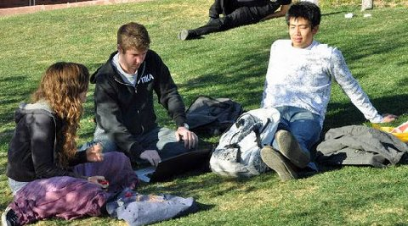
Students at UA have lots of questions for Martha.

FROM THE DESERT
UA, February 12, 2011
With many students already sitting on the hill, I started the day by reading from the Arizona Daily Wildcat, the headline of a front page story read, “UA dean: It’s OK to be gay.”
Feigning an effeminate voice, I read, Lee Jones, the associate dean for student affairs and admissions at the UA's College of Medicine, who has been with his partner for more than 20 years, shared his “coming out” story.
Nervous about his parents' reaction, he had left a voicemail on their recording machine stating, "You need to know I'm gay. Call me when you're ready."

He received no answer from his parents. A few days later, his father called and informed Jones that he had called the wrong number, and left a voicemail on his neighbor's answering machine.

“This is the best thing. Don't you ever do that again. Don't you ever keep such a big part of who you are away from us," Jones quoted his father after the incident.
So now we have a dean, who is also a psychiatrist of a major medical school, telling students in a lecture on campus, that perversion is OK. If one just considers the medical hazards of sodomy, a doctor ought to discourage it. The dean even admitted that, “Gay men are about three times as likely to have an eating disorder than straight men.”
I suggested, “It might be on account of what sodomites eat.”
The students were attentive today and less rambunctious. The Jewish fraternity boy, the one I called “the Broken Record” was not around today. There was not the clamoring for my stories. Therefore, I was inclined to tell of my B.C. days. The students listened attentively as I related, “The Brother Jed Story: The Making and Breaking of a Hippy.”
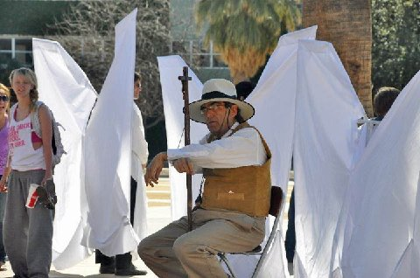
"...The students were attentive today and less rambunctious..."
Kim Jones, who lives in Arizona and was a member of Rosedale Assembly of God in Indiana (my first home church after my conversion), joined me on campus today. After I finished my story, I invited Kim to confirm my testimony. He spoke of his shock when I walked into his church Sunday morning with a long hair and beard and old Levis and Pastor Clyde Swalls introduced me as a new Christian, whom he had led to the Lord the previous night. Kim then told how some weeks after, I came to church with a haircut, clean shaven and a coat and tie and everyone thought I was a visitor.
I exhorted the students, “A Christian will have a life changing story to tell. For when one meets Christ, he is never the same afterwards. Even if one does not accept him as Lord and Savior, he will never forget the encounter.” I want to make sure the students never forget that when I preach they are having a confrontation with the Spirit of the living God, who lives within me.
Next, I spoke on the four questions that any religion or philosophy has to answer. I dwelled on the moral question. When one speaks of Biblical morality often he is challenged on the slavery issue. I do not dodge this question, but nor do I want to spend a lot of time on it. Today, when a philosophically minded student condemned slavery in the Bible, I pressed him, “What is your moral foundation for condemning slavery? To what universal standard are you appealing to say that slavery is wrong?”
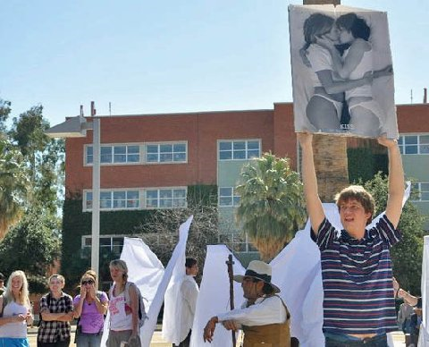
This guy was there last year with the same perverted picture.
After 2 PM I gave Roy the opportunity to speak while I took some time to fellowship with Kim, and his pastor friend, and Mike O. I preached again from 2:30 until 4 PM when I invited Mike O. to give his testimony. After which, I gave a final exhortation to students to read the Bible and visit church on Sunday.
The ASUA Pride Alliance was out in force again today wearing angel wings made out of PVC pipe and sheets. Their flier read, “We are individuals who have come to courageously stand as a barricade between you, and innocent bystander, and this rampant hate-mongering . . . We stand strong. Our mission is to block hate with beauty and end violence through silent, peaceful protestation.”
This “Pride Alliance” is so self-righteous in promoting the gross sin of sodomy. And it is really rather amusing, for as Kim’s pastor friend said, “They are a good backdrop for your preaching.” They draw more attention to me. I do not know how they are demonstrating courage against one man who is standing against a hostile multitude. Nor am I threatening violence. On the other hand perhaps their demonstration unwittingly illustrates the significance of what Jesus said, “And from the days of John the Baptist until now the kingdom of heaven suffereth violence, and the violent take it by force.”—Matt 11:12
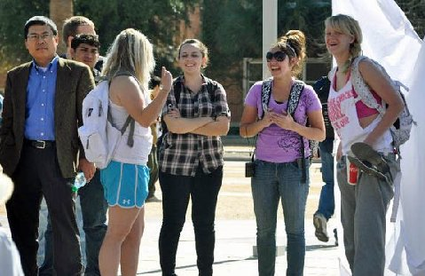
"...I want to make sure the students never forget that when I preach they are having a confrontation with the Spirit of the living God, who lives within me..."
Christians, who take a bold stand for righteous, will suffer violence but with great moral force we must courageously stand against the defenders of sin and the enemies of God. There will be revival when Christians with moral force oppose evil and uphold what little is still right.
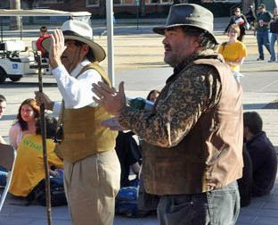
Local resident, Michael O. gives a witness for the Lord Jesus.
There have been few professing Christians in the UA crowd this week. Virtually, no Christians have challenged my message or methods. Perhaps they have been counseled by their leadership to stay away.
I praise God that I am back in Tucson, my favorite place to be in the winter. Since we arrived I have not seen a cloud in the blue sky, the sun is shining brightly and the temperature has been in the high sixties. We preach with a view of the purple mountains in the distance and palm trees in the foreground. God is good.

Thank you for your faithful prayers and support. Please continue to pray for us. You may donate to CMUSA using PayPal by going to our web site brojed.org or by mailing your check to our home address: CMUSA 2402 Longview Dr. Columbia, MO 65203. All gifts are tax deductible. Thank you for your generosity.
Bro. Jed and Martha Marie's Sched

